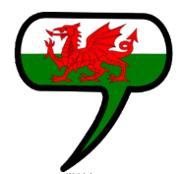
PE – Health and Fitness
Pupils will be participating in a variety of fitness activities. Pupils will explore different components of fitness.
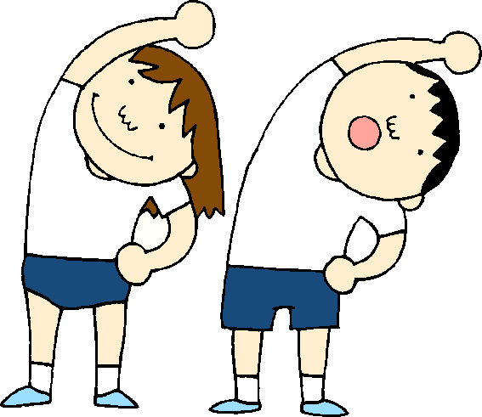
RE
Pupils will study the life of Jesus leading up to the Easter Story.
Pupils will explore the different traditions that Christians celebrate at this time of year.
Big Question
- Where would you prefer to live, Llanrumney or Cardiff Bay?

Stunning Start
Residential to Cardiff Bay
Marvellous Middle
To create and evaluate their work inspired by Rhiannon Roberts
Fabulous Finish
Pupils will have the opportunity to debate as to where they would prefer to live.

Blwyddyn 4
Gwanwyn 2
‘Cardiff Bay’

Welsh
Beth sy’n bod? – What is the matter?
Pupils will ask and respond to questions about their health.
Pupils will create and perform a play script about visiting the doctors.
ICT
Pupils will be exploring internet safety and create a safety video to educate their peers about the dangers of working online.

Numeracy
- Using cm, m, km and miles to measure accurately and convert units.
- Approximating and using scales to measure distance.
- Using decimal notation to compare value of coins.
- Collect, display and compare data.

Creative
Pupils will design and create a fairground ride to feature in Cardiff Bay.
Pupils will study the Welsh Artist Rhiannon Roberts create art inspired by her work.
Topic
Pupils will explore Cardiff Bay and it’s surrounding, locating these on ordinate survey maps. Pupils will learn about the development of Cardiff Bay and how it has changed over time. Pupils will recognise natural and man-made features of Cardiff, and compare and contrast these to their local areas.

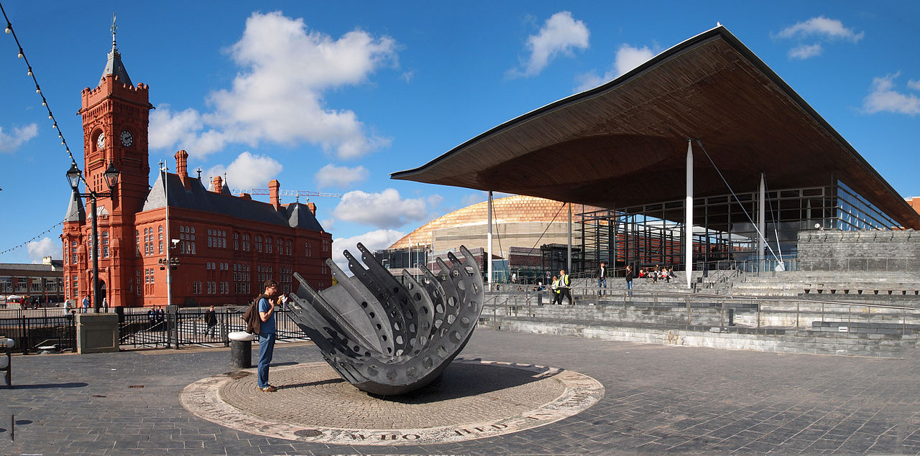
Literacy, Language and Communication
Non-fiction - writing a report based on our visit to Cardiff Bay.

Narrative – writing our own descriptive story set in Cardiff Bay past or present.

