

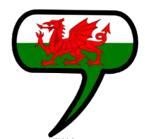
Creative
Learners will be using clay to plan, design and evaluate their own ‘Dragon’s eye’.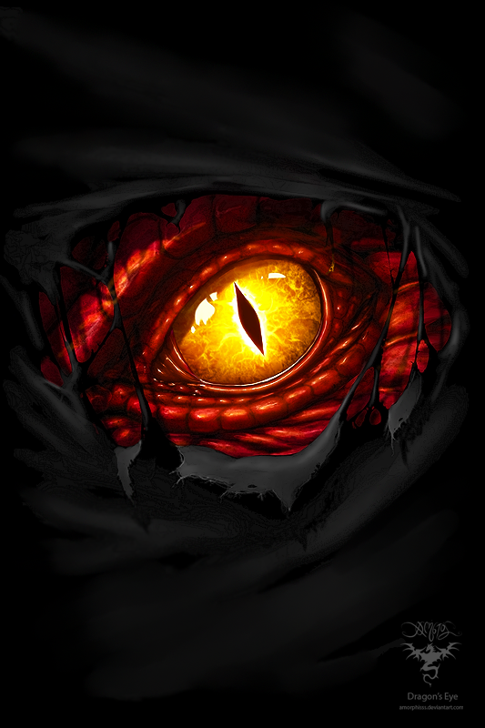
Topic
Learners will explore the castles in Cardiff and Wales and locate these on maps. Learners will learn about the past of Welsh castles and how they have changed over time. Learners will recognise natural and man-made features of Welsh castles, and compare these to castles around the world.

Children will explore the story of our own Red Dragon on the Welsh flag, and how this story is part of our culture.
ICT
Learners will be exploring presentational features when creating Google slides to communicate ideas. Learners will insert text and explore how to resize and change the font.
Learners will insert multimedia in the form of pictures, sound and animations, to allow for their presentations to be engaging to their intended audience.
Welsh
Fi – About Me
Learners will talk about themselves, their likes and dislikes, their appearance and their families.
Big Questions
- Why were castles built in Wales?
- Who lived in Cardiff Castle?
- Why is there a dragon on the Welsh flag?

Blwyddyn 3
Hydref 2
‘Castles and Dragons!’

Literacy, Language and Communication
Non-fiction - writing a recount based on our visit to Cardiff Castle.

Narrative – writing our own mythical story based on the story of
the Welsh Dragon.

Stunning Start
Visit to Cardiff Castle
Marvellous Middle
Storytelling – Welsh Myths and Legends
Fabulous Finish
‘cASTLE bANQUET’
Numeracy
- Using decimal notation in recording money.
- Using halves and quarters in practical situations.
- Approximating to the nearest 10, 100 and 1000.

PE – Competitive Games
Learners will be observing the importance of rules for fair-play, and practising a range of skills that are important for competitive games.
RE
Learners will explore Christianity and why Christmas is celebrated in Wales.


