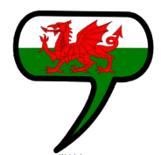
ICT
Using Google slides to present information
Children will apply knowledge and skills of searching and creating databases to our fair-trade topic

Topic
Learners will explore the significance of the Fairtrade brand and the impact of product choices on farmers.
We will consider the importance of treating people fairly, highlighting the issue through unfair trading. We will look at the roles of various positions in the production line and how this is reflected in the pay they receive.
Children will research countries around the world from which we receive our food and the journey from field to fork.

Stunning Start
VR experience
Marvellous Middle
Engaging and interactive activities to further enhance knowledge of topic.
Fabulous Finish
TASC – How can I creatively show my learning?
Creative
Children will create a unique poster reflecting the values of the Fairtrade brand using a variety of materials.
Welsh
- Welsh Alphabet
- Ar y penwythnos
- Anifeiliad Anwes from around the world
Learners will develop their Welsh speaking, reading and writing skills through the topics of the weekend and animals around the world.
Big Questions
- What is Fairtrade?

- Who does it affect?

- How can we help?
Blwyddyn 3/Haf 2
‘Fairtrade’
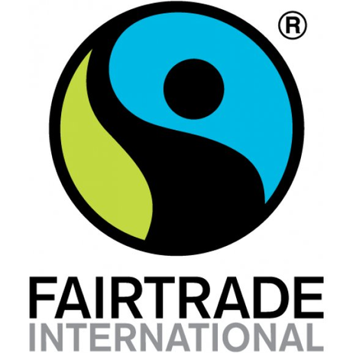
Literacy, Language and Communication
- Persuasive writing – children will use their knowledge of Fairtrade to persuade others of its importance.
- Poetry – exploring various poetic forms and techniques, children will write their own poems based around our Fairtrade topic.
Numeracy
- Four operations – addition, subtraction, multiplication and division.
- Handling data – interpreting and communicating data through bar graphs and pictograms.
- Reasoning

PE – Athletics
Exploring skills needed for different athletic activities, including, sprinting, javelin and relay.
RE
Children will explore the core values of The Five Pillars of Islam and Christianity.

