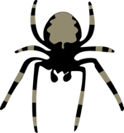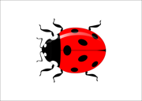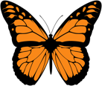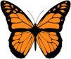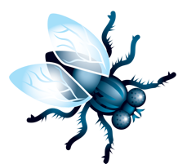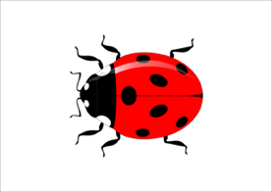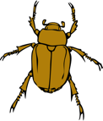
Big questions
- Where do minibeasts live?
- How many legs does a minibeast have?
- What types of minibeasts are there?
Stunning start
Super worm Story
Marvellous Middle
Visit from RSBP
Fabulous Finish
Visit from Zoolab
ICT
- Exploring a range of videos and PowerPoints about minibeasts.
- Practicing giving and following instructions.
PE
We will continue with our daily yoga practice as well as cosmic yoga sessions to link with minibeasts!
As well as this we will be continuing learning our movement sequences to some of our favourite Disney songs across a series of sessions!

Reception Summer 1
Topic: Minibeasts
Wriggle and crawl
Welsh Language Development
- Learning colours and numbers in Welsh.
- Singing songs about minibeasts.
- Listening to stories about minibeasts.
- Learning new language patterns of – ‘Dwi’n hoffi/ dwi ddim yn hoffi’.
- Revisiting the weather ‘y tywydd’ in Welsh.
Physical Development

- Manipulating and exploring a range of materials like large hoops to create spider webs
- Using variety of large equipment, mats, hoops, benches, tunnels
- Punching holes in large leaves
- Threading leaves
- Using tweezers to collect ‘worms’ and ‘flies’ from a pretend spiders webb!
Mathematical Development

- Exploring 2D shapes
- Understanding symmetry through exploring butterfly’s symmetrical patterns.
- Singing number songs and
- Learning about capacity by measuring beetle juice.
- Measuring worms and finding the longest and shortest.
- Exploring doubles through minibeasts legs.
- Estimating amounts of minibeasts in jars.
- Adding and subtracting simple amounts.
Knowledge and understanding

- Learning about melting and solidifying by making jelly worms and rescuing plastic insects from ice.
- Making edible worms from strawberry laces and chocolate cake!
- Being a nature detective by going on a bug hunt.
- Learning about life cycles of caterpillars.
- Sorting minibeasts by their characteristics and habitats.
Personal & Social Development, Wellbeing and Cultural Diversity

-Caring for minibeasts in the environment
-Learning about and caring for minibeasts habitats.
-Taking turns when handling bugs during a zoo lab visit.
-Exploring the outdoors.
Language, Literacy and Communication

- Writing poems about worms
- Listening to a range of fictional and non-fictional stories – such as ‘The very hungry caterpillar’, ‘Super worm’, ‘The very busy spider’.
- Re-enacting and re-telling events from stories.
- Listening to and following e-books related to minibeasts.
- Writing fact files about a minibeast.

Creative Development

- Exploring and create with a range of materials by making bottle top spiders, creating bugs and webs with playdough and bug fossils with clay.
- Developing our understanding of shape and pattern through drawing and painting minibeasts
- Singing rhymes and songs about minibeasts.
- Exploring symmetry with butterfly patterns.

