
RE:
Value the learning, success and achievements
of themselves and other people

PHSE: Be aware of and respect the needs of others

? Big Questions ?
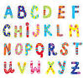


PE

Begin to understand that regular exercise improves health and fitness and that it helps body parts to work well

Literacy
Writing
To identify letter sounds.
Write own name

Speaking & Listening
To understand and use
simple questions.
Answer simple questions and open
ended questions.

Reading
Peace At Last
Big Red Bath

Numeracy
Number and Place Value:
Understand concept of one more and more less.
Addition and Subtraction:
To recite numbers from 0 to 10 forwards and backwards using songs and rhymes
Measurement:
To use direct comparisons in weight, length, height.





Can I help you?
Who helps you? How?

Stunning Start
Visiting people who help us at home and in school
Marvellous Middle
Visit shops, leisure centre, refuse centre, vets
Fabulous Finish
Dress up Day of your favourite ‘Helper’
Nursery – Spring 2
People who help us

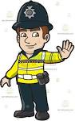
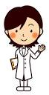
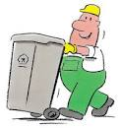



Knowledge and understanding of the World
Become aware of human achievements and the ‘big ideas’ that have shaped the world; recycling, medical ‘helpers’
Recognise how people’s actions can improve or damage the environment.

Welsh
Cwestiwn Mawr –
Ga i helpu ti?
Pwy sy’n helpu ti? Sut ydy chi’n helpu ti?


Creative development
Develop and use their understanding of colour, line, tone, texture, pattern, shape and form.

Begin to recognise familiar music and simple routines, and respond by joining in or moving
to the music, broadly imitating actions, sounds and words.

