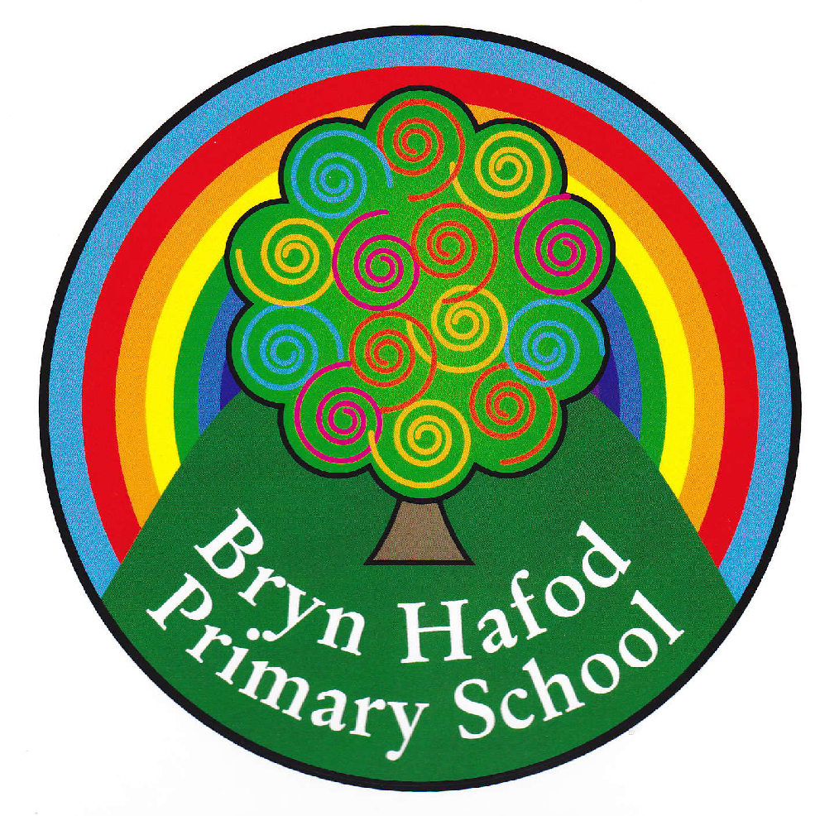
SRB Home Learning.
Topic : not applicable
Choose any of the Home Learning tasks below. You can complete as many as you wish – you do not need to complete all of them! Please bring any work you complete into school so we can share this throughout our topic. Diolch yn fawr!

Humanities  Make a sensory potion with different textures such as shower gels and bath bombs for halloween  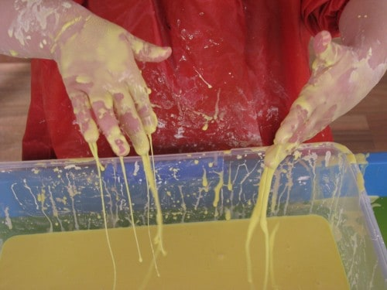 | Literacy  Mr N class. Play alphabet rhyme to your children  https://www.youtube.com/watch?v=BELlZKpi1Zs  Mrs Davies- practice handwriting of the alphabet a-z focusing on letter formation. | Health & Well-Being  It is important that we keep ourselves fit and healthy. Yoga is a brilliant way to exercise your body and mind. Follow the links below, you could even ask your grown up to join in…  Cosmic Yoga – choose your own episode
Reading  Share a book with your child daily of possible. Take a photo of the task and post it on seesaw for all to see.  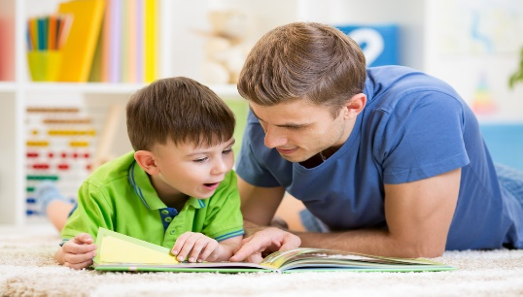 | Expressive Arts  Make a picture of your own face using natural materials such as leaves etc. Send in to class  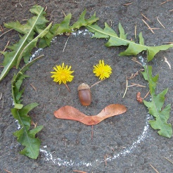 | Maths  Listen to these songs with your child to help with  Days of the week and months of the year  https://www.youtube.com/watch?v=mXMofxtDPUQ  https://www.youtube.com/watch?v=5enDRrWyXaw

