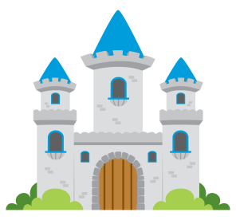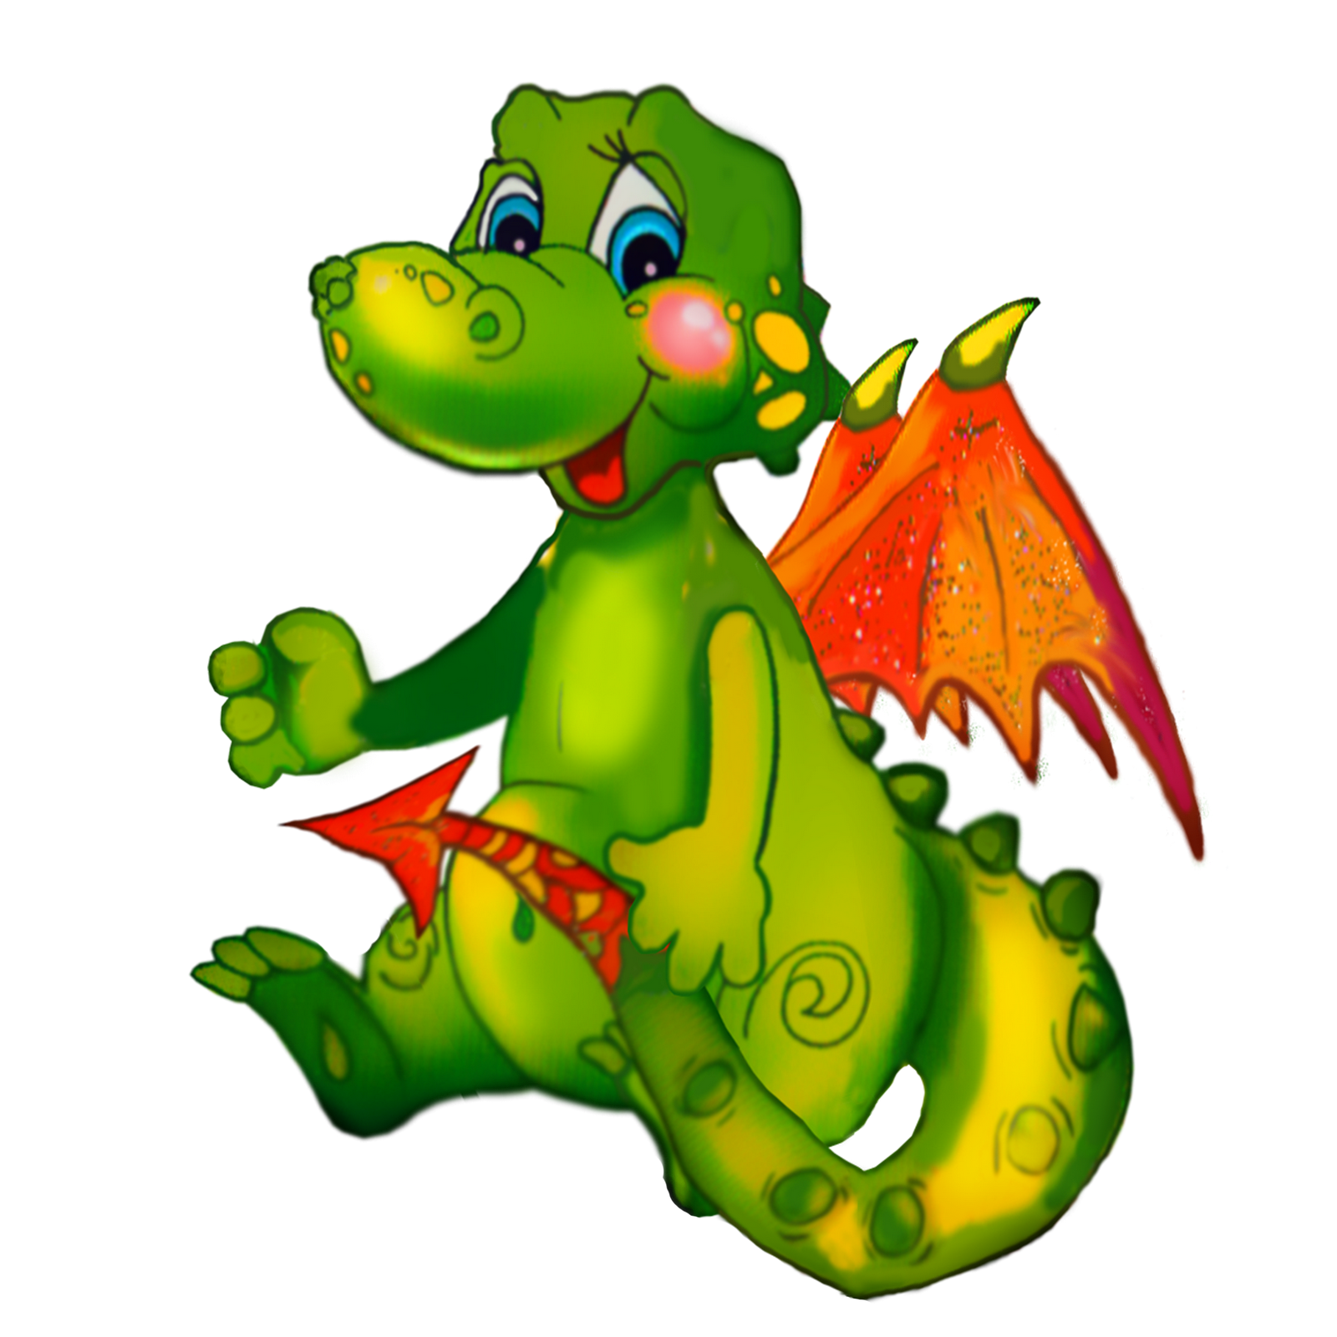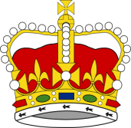
Literacy
Distinguish between upper and lower case letter
Writing our own fairytale stories
Features of knowledge traditional stories
Developing our ability to plan using story mountains
Using time connective
Developing our ability to write extended sentences

RE
Ble wyt i’n byw?
Bwyd
Dw i’n hoffi
Dw i’n ddim yn hoffi
Encourage the use of incidental Welsh through our school day.

PSE
Collaborative learning
How words, actions and events can affect other peoples’ feelings
Developing aware of our own feelings and the feelings of others
PE Term
Learning an range of Welsh Folk Dances
Maths
Money – coin recognition, combinations of money, working out change
Addition and subtraction
Division and multiplication – grouping
Reasoning and problem solving
1 step and 2 step word problems
Half, quarters, whole and right angles
Temperature – reading temperature and compare

Creative Development
3d Dragons with movable parts
Special persons card with moving part
Observation drawings of castles
Welsh artist

KUW
Looking at features of castles
Compare castle from around the world
Learning about people from the part
Developing understanding of Welsh Traditions
Visiting Castell Coch

Dragon Tales
Spring 2

